Regulations:
A14

H.T No

Sreenidhi Institute of Science and Technology
(An Autonomous Institution)
Code No: 4H214 Date: 28-Dec-2018 (FN)

B.Tech I-Year II-Semester End External Examination, Dec-2018/Jan-2019 (Supplementary)
Mathematics for Biotechnology - II (BT)

Time: 3 Hours Max.Marks:70

Note: a) No additional answer sheets will be provided.
b) All sub-parts of a question must be answered at one place only, otherwise it will not be valued.
c) Missing data can be assumed suitably.

Part - A Max.Marks:20

Answer all QUESTIONS.

1. | Find the integrating factor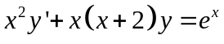. | [2M]
2. | Find the particular integral of the differential equation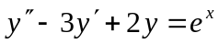. | [2M]
3. | Form the partial differential equation by eliminating the arbitrary constants for the equation 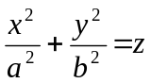 where a, b are arbitrary constants. | [2M]
4. | Write Dirichlet’s conditions for Fourier series expansion of a function. | [2M]
5. | Find the Laplace transform of the function 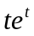. | [2M]
6. | Find 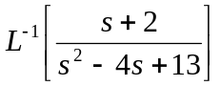 | [2M]
7. | State Newton’s law of cooling. | [2M]
8. | Solve 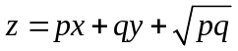 | [2M]
9. | If 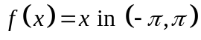 then find the Fourier coefficient 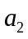. | [2M]
10. | Evaluate 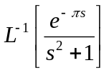 | [2M]
Part – B Max.Marks:50
ANSWER ANY FIVE QUESTIONS. EACH QUESTION CARRIES 10 MARKS.

11. | a) | Solve 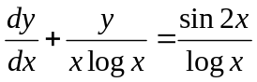 | [5M]
 | b) | Solve 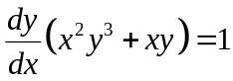 | [5M]
12. | a) | Solve 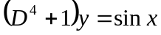 | [5M]
 | b) | solve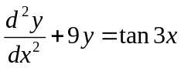 by the method of variation of parameters. | [5M]
13. | a) | Find the partial differential equation for 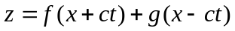 by eliminating 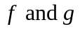 | [5M]
 | b) | Solve 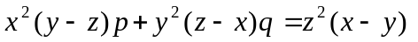. | [5M]
14. | a) | Find the half-range sine series for 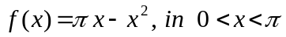 | [5M]
 | b) | Find the Fourier series for 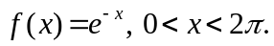 | [5M]
15. | a) | Find the Laplace transform of 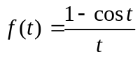 | [5M]
 | b) | Find the Laplace transform of 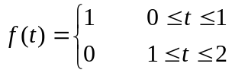 and 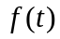 is a periodic function with period 2. | [5M]
16. |  | Solve where 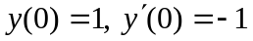 by using Laplace transforms. | [10M]
17. |  | Solve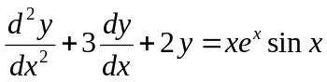. | [10M]
18. |  | Using Convolution theorem, evaluate 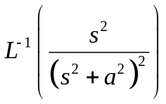 | [10M]

-- 00 -- 00 –

